**HUMAN BIOLOGY YEAR 11 ATAR**

**TEST 3: EXCRETORY & MUSCULOSKELETAL SYSTEMS**

**TOTAL MARKS: 65**

**SECTION A: MULTIPLE CHOICE (30 MARKS):**

1. Approximately 1.5L of urine is passed each day by a healthy person. Which of the following could be cause for concern in regards to urine passed?
   1. the urine is around 99% water
   2. the urine contains glucose
   3. the urine has a pale yellow colour
   4. the urine does not contain significant amounts of protein
2. The correct order of the major processes occurring in the kidneys is
   1. glomerular filtration, reabsorption, tubular secretion
   2. reabsorption, tubular secretion, glomerular filtration
   3. tubular secretion, reabsorption, glomerular filtration
   4. glomerular filtration, tubular secretion, reabsorption
3. Which of the following organs are **NOT** involved in excretion of wastes?
   1. lungs
   2. stomach
   3. kidneys
   4. sweat glands in the skin
4. The kidneys remove nitrogenous wastes from the body. Choose the correct list of these wastes
   1. water, urea and bile
   2. urea, uric acid and creatinine
   3. uric acid, urea and salt
   4. urea, creatinine and salt
5. Urea is a metabolic product from the breakdown of
   1. Glucose
   2. Lipids
   3. Proteins
   4. Alcohol
6. The renal pelvis opens directly into the
   1. Urinary bladder
   2. Ureter
   3. Gall bladder
   4. Urethra
7. Filtration of the blood circulating through the kidney nephron occurs between the
   1. Glomerulus and the renal capsule
   2. Efferent arteriole and the proximal convoluted tubule
   3. Capillary network and the Loop of Henle
   4. Afferent arteriole and the collecting duct
8. Which of the following does NOT occur in the kidneys?
9. filtration
10. reabsorption
11. secretion
12. deamination
13. Excretion is the removal of:
14. liquid wastes
15. undigested waste
16. substances not needed
17. wastes from cell processes

Use the diagram below to answer the next two questions.

B

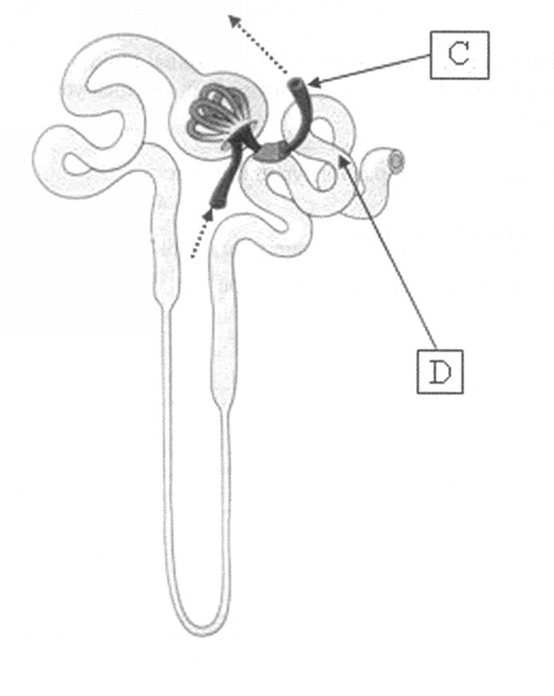

E

A

1. Structure C is the
2. afferent arteriole
3. collecting duct
4. efferent arteriole
5. glomerulus
6. Which of the following structures would contain the greatest concentration of urea?
7. A
8. B
9. C
10. D
11. An obstruction in the glomerulus in a nephron would block the flow of blood into the
12. renal artery.
13. efferent arteriole.
14. glomerular capsule.
15. afferent arteriole.
16. Urine is carried to the urinary bladder by
17. blood vessels.
18. lymphatics.
19. the ureters.
20. the urethra.

***Questions 14 and15 refer to the figure below.***

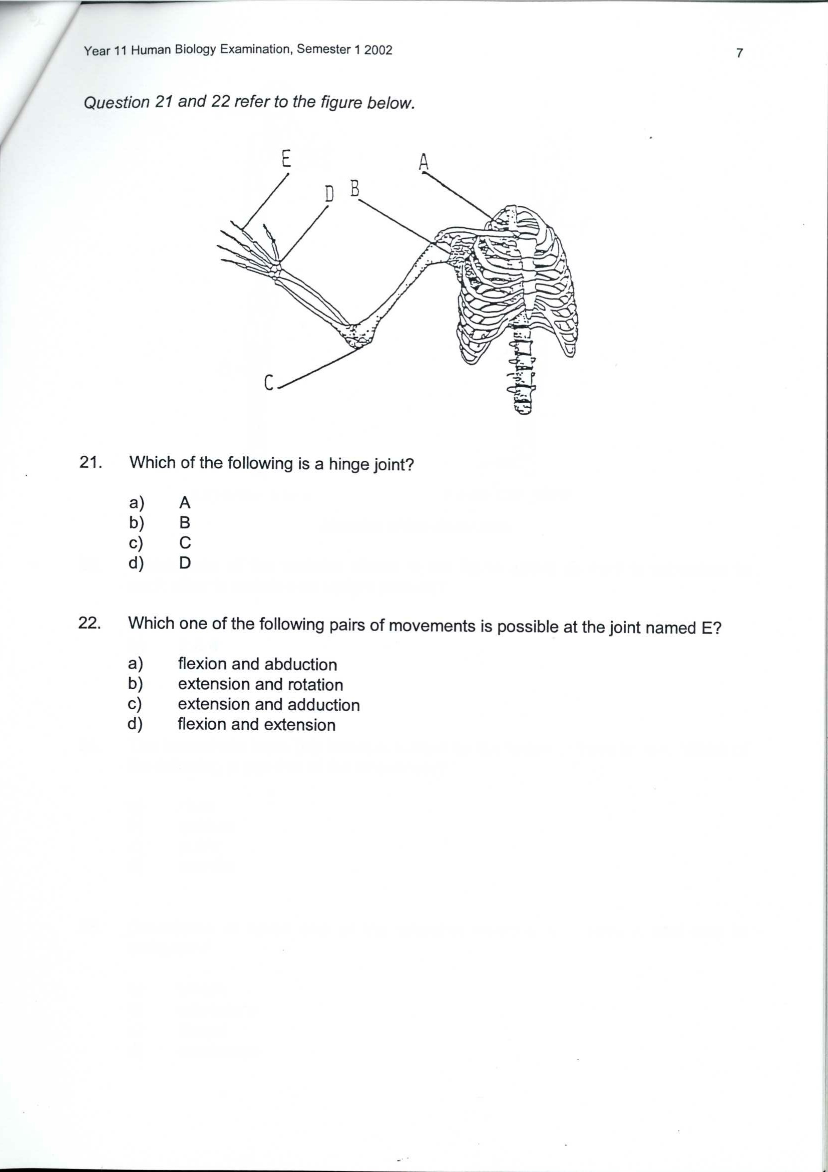

1. Which of the following is a hinge joint?
2. A
3. B
4. C
5. D
6. Which one of the following pairs of movements is possible at the joint named E?
7. flexion and abduction
8. extension and rotation
9. extension and adduction
10. flexion and extension
11. The shaft of a long bone is called the
12. periosteum
13. trabuculae
14. diaphysis
15. epiphysis
16. Mature cartilage cells are called
17. osteocytes
18. chondrocytes
19. osteoblasts
20. chondrin
21. Contraction of which one of the following muscles will cause a bent arm to straighten?
22. triceps
23. extensions
24. biceps
25. quadriceps
26. Our skeleton
27. produces red and white blood cells in its marrow.
28. offers protection to delicate organs such as the small intestine.
29. is hard due to the deposition of fluoride and phosphorous.
30. allows for the attachment of smooth muscles so we can move
31. The joint between two vertebrae is an example of a
32. fixed joint
33. hinge joint
34. slightly moveable joint
35. pivot joint
36. The vertebral column rib cage and skull form the
37. axial skeleton
38. appendicular skeleton
39. pectoral girdle
40. pelvic girdle
41. Each of the following pairs of bones have a synovial joint between them EXCEPT:
42. the ulna and the humerus
43. the scapula and the humerus
44. the tibia and the femur
45. two sacral vertebrae
46. Spongy bone
47. is very soft
48. often contains red bone marrow
49. makes up most of the diaphysis of a long bone
50. has the lamellae arranged in concentric layers
51. The type of cartilage present at the ends of articulating bones at synovial joints is
52. fibrocartilage
53. elastic cartilage
54. hyaline cartilage
55. synovial cartilage
56. Myofibrils are made up of
57. thick myofilaments made up of actin and thin myofilaments made up of myosin
58. thick myofilaments made up of myosin and thin myofilaments made up of actin
59. thin myofilaments made up of either myosin or actin
60. thick myofilaments made up of either myosin or actin

The next question refers to the following diagram.

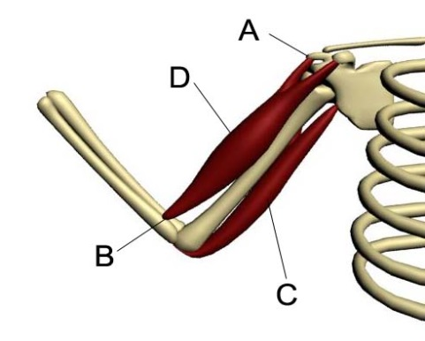

Source picture created by Clinton Ellard

1. The correct names for the labels A, B, C and D above show:
2. insertion, origin, biceps, triceps,
3. origin, insertion, biceps, triceps,
4. insertion, origin, triceps, biceps
5. origin, insertion, triceps, biceps
6. The membrane surrounding the outside of the bone is called the
7. periosteum
8. chondosteum
9. endosteum
10. osteometrium
11. A muscle which straightens a limb is called a(an)
12. extensor
13. flexor
14. adductor
15. abductor
16. The muscle that opposes movement around a joint is called a(n)
17. agonist
18. antagonist
19. fixator
20. synergist
21. This question refers to the diagram below, which shows the sliding filament model of muscle contraction.



The diagram above predicts that during muscle shortening

1. Z lines move further apart, A bands shorten and I bands lengthen.
2. Z lines are drawn closer together, A bands remain the same and I bands lengthen.
3. Z lines move further apart, A bands lengthen and I bands shorten.
4. Z lines are drawn closer together, A bands remain the same and I bands shorten.



**HUMAN BIOLOGY YEAR 11 ATAR**

**TEST 3: EXCRETORY & MUSCULOSKELETAL SYSTEMS**

**ANSWER SHEET**

**NAME:**

**SECTION A: MULTIPLE CHOICE: (30 MARKS):**

*Place an* **×** *through the correct response:*

1. [A] [B] [C] [D] 16. [A] [B] [C] [D]

2. [A] [B] [C] [D] 17. [A] [B] [C] [D]

3. [A] [B] [C] [D] 18. [A] [B] [C] [D]

4. [A] [B] [C] [D] 19. [A] [B] [C] [D]

5. [A] [B] [C] [D] 20. [A] [B] [C] [D]

6. [A] [B] [C] [D] 21. [A] [B] [C] [D]

7. [A] [B] [C] [D] 22. [A] [B] [C] [D]

8. [A] [B] [C] [D] 23. [A] [B] [C] [D]

9. [A] [B] [C] [D] 24. [A] [B] [C] [D]

10. [A] [B] [C] [D] 25. [A] [B] [C] [D]

11. [A] [B] [C] [D] 26. [A] [B] [C] [D]

12. [A] [B] [C] [D] 27. [A] [B] [C] [D]

13. [A] [B] [C] [D] 28. [A] [B] [C] [D]

14. [A] [B] [C] [D] 29 [A] [B] [C] [D]

15. [A] [B] [C] [D] 30. [A] [B] [C] [D]

**SECTION B: SHORT ANSWERS (35 MARKS):**

1. This question refers to the diagram shown below.

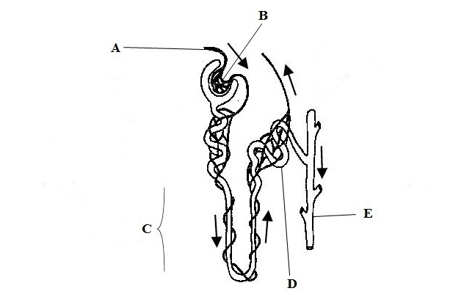

**A**

1. (i) The structure shown in the diagram is known as the functional unit of the kidney. What is it called? (1 mark)

(ii) Name the parts listed below. (2 marks)

B:

E:

(iii) State the function of the parts listed below. (2 marks)

A:

C:

(iv) Explain why structure D is convoluted rather than being a straight tube. (2 marks)

1. What is deamination? (1 mark)

1. Where does it occur? (1 mark)

1. What is the name of the toxic substance produced? (1 mark)

1. What is the name of the substance that this toxic substance is rapidly converted into and then excreted from the body? (1 mark)

1. Use the diagram of a kidney to fill in the missing labels

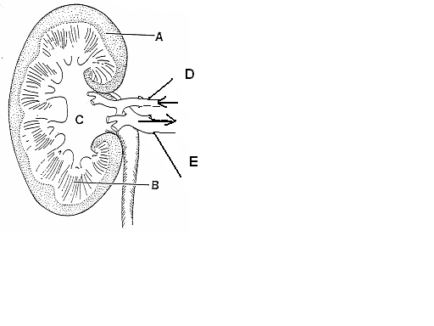

* 1. A   
       
     B   
       
     C   
       
     D   
       
     E

(5 marks)

* 1. 1. What is the name of the structure that INITIALLY filters the blood in the kidney
     2. The tube leading from the kidneys to the bladder is called

* + 1. The tube leading from the bladder to the outside is called?
    2. What happens to the urine output if the body fluids contain less water than normal?

(4 marks)

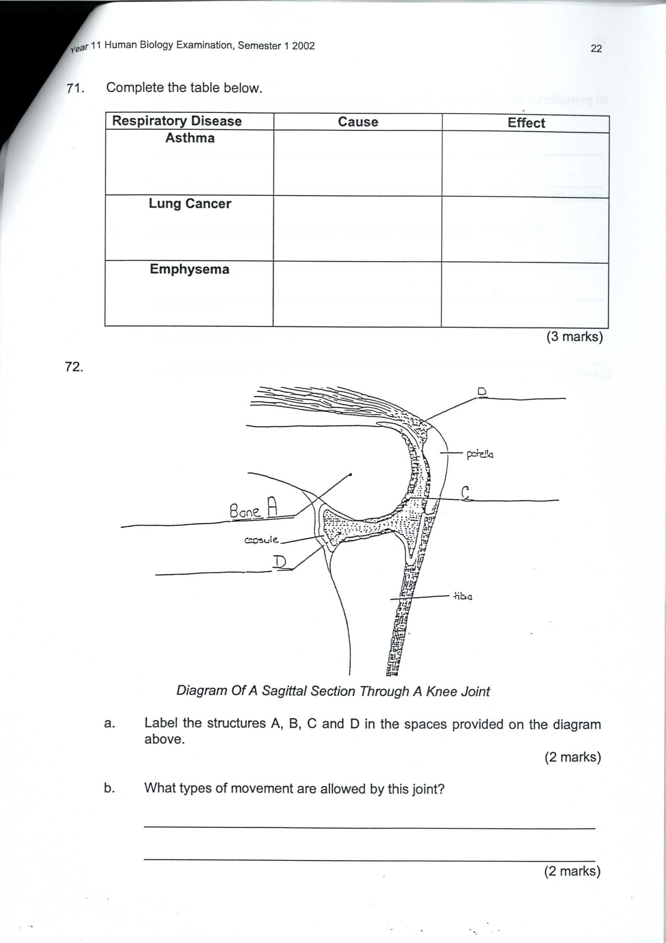

*Diagram Of A Sagittal Section Through A Knee Joint*

1. Label the structures A, B, C and D (2 marks)

A

B

C

D

1. What types of movement are allowed by this joint? (1 mark)

1. Explain the roles played by structures C and D in the efficient functioning of the knee. (2 marks)

1. Distinguish clearly between the functions of ligaments and tendons. (2 marks)

1. Use the following diagram of the human upper limb to answer the following questions.

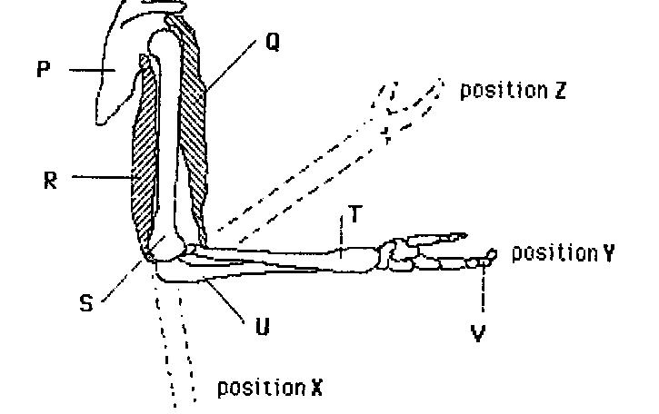

* 1. Label the parts P, Q, T and U as shown in the diagram.

P

Q

T

U

* 1. What type of joint exists between
     1. Bone S and bone U.

* + 1. Bone P and bone S

* 1. If the forearm moves from position Y to position Z,
     1. which letter in the diagram represents the muscle that is contracting to enable this movement?

* + 1. What is the name of this muscle?

* + 1. What is the name of its antagonist?

* 1. What type of movement is occurring when the forearm is moving from position Y to position X?

(8 marks)

*END OF TEST*